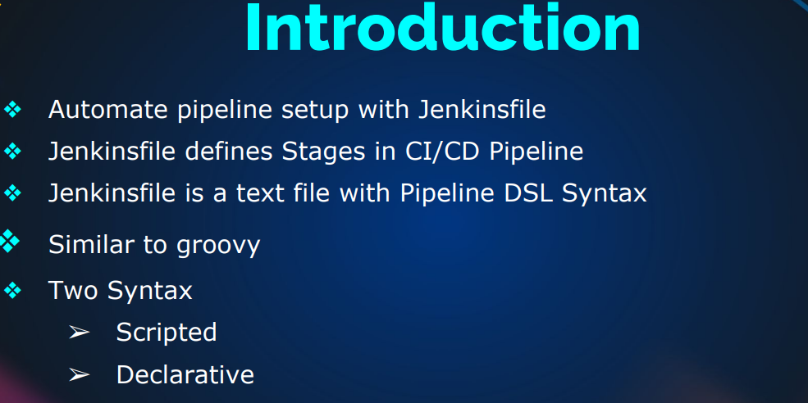

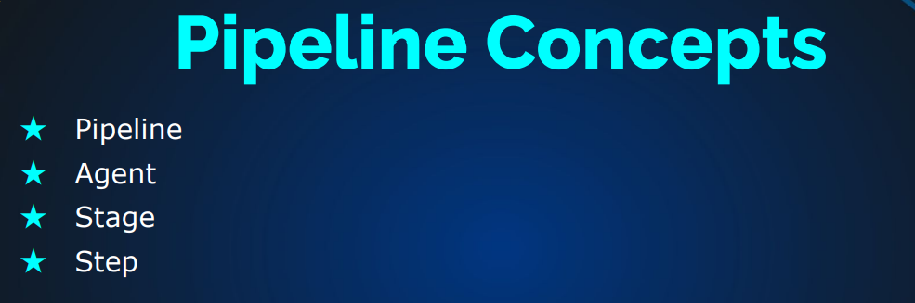

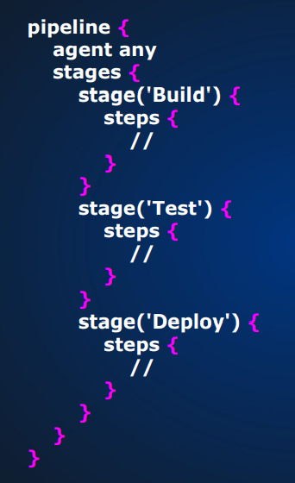 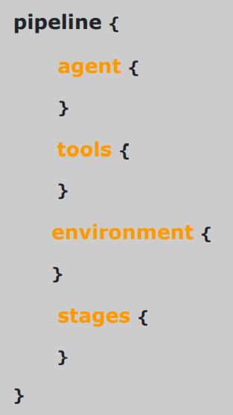

**Jenkins Jobs**

Jobs basically means workload. There are two types of jobs:

* Freestyle Jobs:
* Graphical jobs
* Used for Learning, Understanding & exploring Jenkins
* Not recommended in Real time now
* Pipeline As a code
* Pipeline
* It is recommended now

Installing Tools in Jenkins:

* create an EC2 instance and provision it with the Jenkins code to install (check doc-bash scripts to install Jenkins)
* Get the public IP and use it to access through your browser
* once it opens, cat into the password path you see in the page to get the login password
* once you have access, click on manage Jenkins, ,,,,, click on global tool config …….. click on add jdk(Name=OracleJDK8) ……… uncheck the install automatically option
* go to git bash and ssh into the EC2 instance to continue (ssh –i Downloads/(keypair) ubuntu@(IP)
* sudo apt update …….. sudo apt install openjdk-8-jdk –y
* java –version ….. to check current running Java
* sudo –i
* ls /usr/lib/jvm …… to check the java for tools if you see java 1.8 then you are good
* /usr/lib/jvm/java-1.8.0-openjdk-amd64 …… to specify the working path
* go back to your AWS console and paste the working path (/usr/lib/jvm/java-1.8.0-openjdk-amd64) under JAVA HOME
* scroll down to add maven in the same page on your AWS console (Name=MAVEN3, version=3.8.6)

Check Doc: How to create jobs in Jenkins